Business Problem
Mint Classics operates four warehouses storing collectible model vehicles. The company aims to improve warehouse efficiency and reduce inventory costs while maintaining customer service levels.
This project analyzes warehouse utilization, product performance, inventory investment, and revenue contribution to identify opportunities for operational optimization.

Key Findings
- Warehouse South stores the lowest revenue-generating product categories despite having the highest warehouse utilization (75%).
- Classic Cars generate the highest revenue and inventory investment.
- Approximately one-quarter of products have significantly higher inventory coverage than the portfolio average.
- One product (1985 Toyota Supra) has never been sold, representing dead inventory.
- Product lines are allocated exclusively to specific warehouses, creating operational concentration risk.

Recommendations
- Review inventory replenishment policies for products with excessive inventory coverage.
- Reallocate inventory based on actual sales performance instead of historical warehouse allocation.
- Investigate the business justification for exclusive warehouse assignment by product line.
- Liquidate obsolete inventory.

1. Dataset Overview
Table | Description
warehouses | 4 storage locations (North, East, West, South) with capacity information
products | Classic model cars and vehicles with stock quantities and warehouse assignments
productlines | 7 productline (Classic Cars, Motocycles, Planes, Ships, Trains, Trucks and Buses, Vintage Cars)
orders | There is 326 orders within range from 06-01-2003 to 31-05-2005 (28 months)
orderdetails | Line-item details for each order (quantity ordered, price)
customers | Customer contact and credit information
employees | Sales representatives and their office assignments
payments | Payment records linked to customers

4. Warehouse Performance

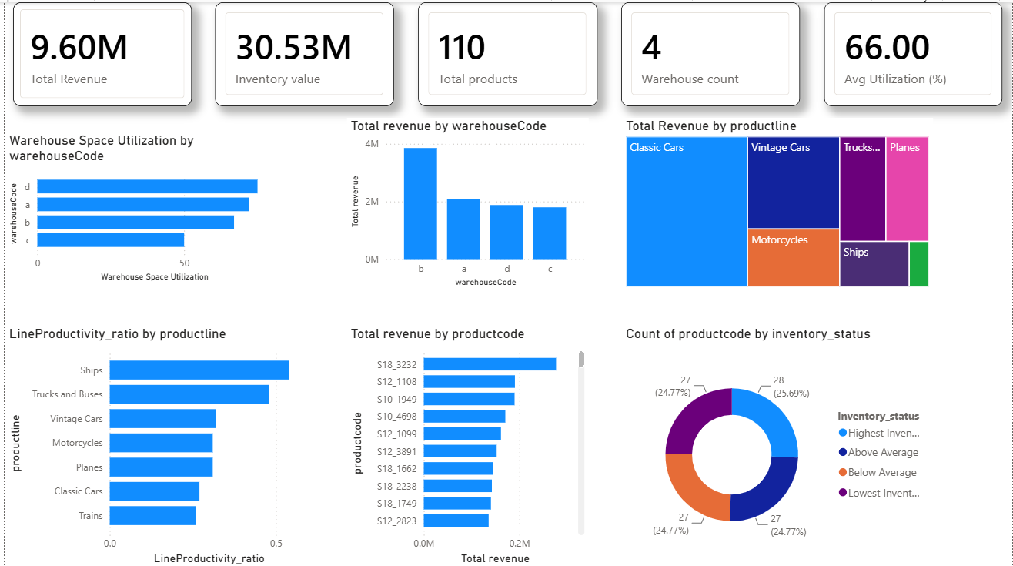Warehouse Capacity
Warehouse South demonstrates the highest space utilization at approximately 75%, indicating efficient use of available storage capacity. In contrast, Warehouse West is utilizing only around 50% of its available space, suggesting potential excess capacity.
Industry best practice generally targets warehouse utilization between 70% and 90%, balancing storage efficiency with sufficient operating space for material handling and peak-season demand.
Further analysis should determine whether the underutilized capacity at Warehouse West is justified by business requirements or presents an opportunity for consolidation.

Revenue Productivity
Warehouse D demonstrates the highest inventory productivity, generating the greatest revenue relative to its inventory investment.
Warehouse B records the lowest inventory productivity; however, it contributes the largest share of company revenue, indicating that its inventory supports strategically important products despite lower efficiency.
Warehouses A and C operate at moderate levels across both revenue contribution and inventory productivity, without significant outliers.
Evaluating warehouse performance should consider both operational efficiency and strategic revenue contribution rather than relying on a single KPI.

Product Allocation
Warehousecode | Productline
a | Motorcycles + Planes
b | Classic Cars
c | Vintage Cars
d | Ships + Trucks and Buses + Trains

Rather than distributing all product lines across warehouses, Mint Classics allocates entire product families to dedicated warehouses.
This simplifies warehouse operations but increases dependency on individual facilities. Any warehouse disruption directly impacts the availability of specific product categories.

5. Product Performance

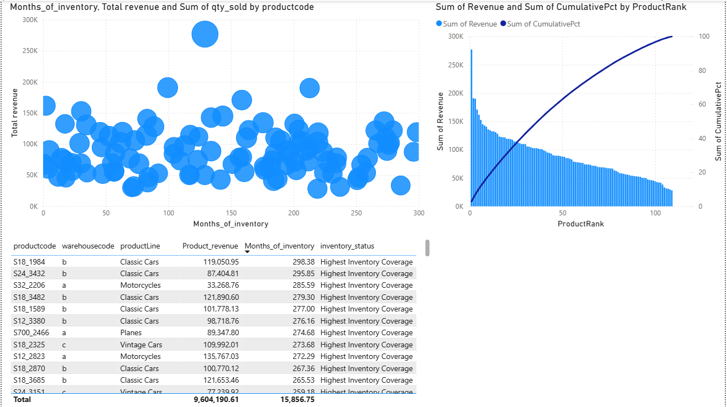
Several products exhibit exceptionally high inventory coverage, exceeding 200 months based on historical average sales. This suggests inventory levels substantially exceed recent demand. However, because supplier lead-time information is unavailable, these products should be treated as candidates for further review rather than automatically classified as excess inventory.

6. Key Findings
- Product lines are fully segregated by warehouse.
- Warehouse West has the largest available capacity.
- Classic Cars contribute the highest revenue.
- Dead inventory exists.
- Inventory investment is concentrated in a small number of products.
- Several products have unusually high inventory coverage.

7. Recommendations
- Review products with the highest inventory coverage for potential inventory reduction.
- Investigate dead inventory (e.g., 1985 Toyota Supra) and consider liquidation or promotional campaigns.
- Evaluate warehouse allocation strategy to determine whether exclusive product-line storage remains operationally efficient.
- Develop inventory policies using demand forecasts and supplier lead times once additional operational data becomes available.

8. Limitations
- Product dimensions are unavailable, so warehouse utilization is based on capacity percentages rather than physical storage space.
- Supplier lead-time data is unavailable, preventing calculation of safety stock and reorder points.
- Analysis is based on historical data (Jan 2003–May 2005) and does not account for future demand changes.

9. Conclusion
This analysis demonstrates how SQL and Power BI can be combined to transform operational warehouse data into actionable business insights. The findings identify opportunities to improve inventory efficiency, reduce excess stock, and optimize warehouse utilization while highlighting areas where additional operational data would enable more robust decision-making.

